

***Student Name: Haya Ameer Hussain***

***Id: BAI-23S-071***

***Year: 2023***

***Semester: 2nd***

***Section: 1st***

***Spring/Fall: Fall***

***Program code:***

***Course Teacher: Miss Aqsa Umer***

***Table Creation Queries Related To Project:***

***(i)Create a new table for patient details:***

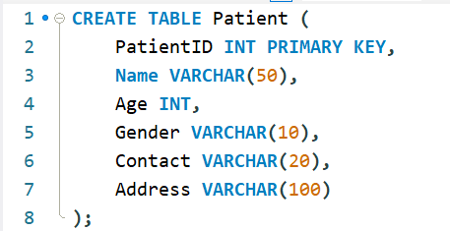

***(ii)Add a table for doctor information:***

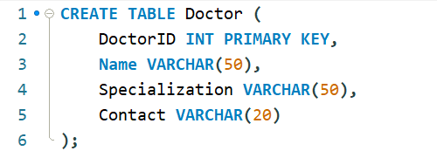

***Table Insertion Queries Related To Project:***

***(iii)Insert a new patient record:***



***(iv)Add a doctor's information:***



***Table Alter Queries Related To Project:***

***(v)Add a new column to the Patient table:***



***(vi)Modify Doctor table column data type:***



***Table Constraint Queries Related To Project:***

***(vii)Add a Foreign Key constraint to link tables:***



***(viii)Create a Check constraint for Age in Patient table:***



***Table Join Queries Related To Project:***

***(ix)Perform an Inner Join between Patient and Doctor tables:***

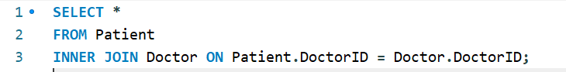

***(x)Retrieve patient details with associated records using LEFT JOIN:***

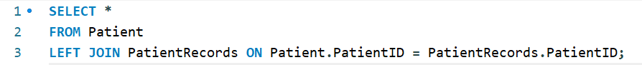

***(xi)Calculate the average age of patients:***



***(xii)Count the number of patients:***



***(xiii)Retrieve patients with specific doctors:***



***(xiv)Find patients with no records:***

